Creating a Subscription

- Click the blue button (see below) provided in the PPM email titled:
    - “Trinity [[Deal Name]] Investors LLC – PPM and Subscription Package”
  - There are separate links for Preferred Equity and Mezzanine Debt, so make sure you navigate to the correct email.
  - If you do not have the desired offering email, contact clientrelations@trinityinvestors.com for a link.

Trinity ______ Investors LLC - Preferred Equity | Trinity______ Investors LLC - Mezzanine

- Click “Create my subscription.”

- Fill out “Investment Amount” and “Subscriber Identity” sections.
  - Select the correct entity you intend to invest through (individual, joint, LLC, IRA, Trust, etc.) (See Below)

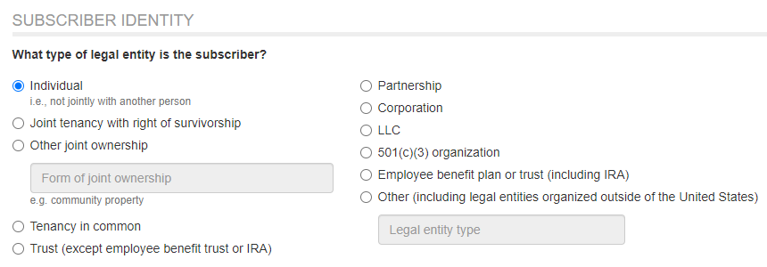

  - Make sure “Subscriber’s full legal name” matches the entity you are investing through.
    - Ex. “James Smith”
    - Ex. “Madison Trust Company Custodian FBO James Smith IRA #0000000”
    - Ex. “James Smith Ventures LLC”

- Fill out bank name and account information.
  - If investing through an IRA, input the Custodian’s routing and account number.
    - Click “Add additional instructions” and type “FBO [[Your Name IRA #0000000]]”

- Fill out Accredited Investor / Qualified Purchaser status.
  - If none of the statements apply, select the bottom option “I do not currently qualify for Accredited Investor Status” (See Below)
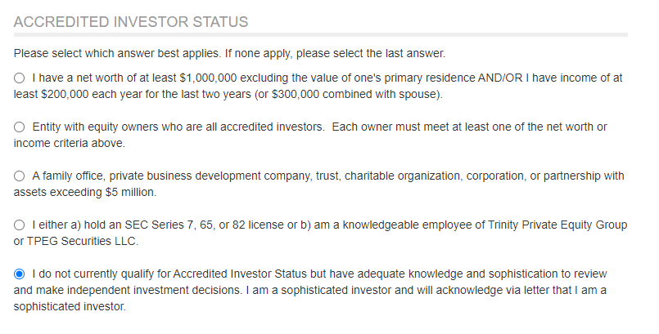

- Add any additional contacts to receive communications and specify which types of communications they should receive.
  - Ex. Tax Advisor, Accountant, Executive Assistant
  - If you invested in an entity with more than one owner, the other signatories would automatically receive all communications.

- Review your questionnaire and verify that all information is correct, then click “Sign Electronically” at the bottom.

- Click “Sign via DocuSign”
  - You do not need to upload any additional documents to this page.

- Check your inbox for an email from DocuSign containing your subscription agreement and follow the promptings.
  - If your agreement has multiple signatories, it will be sent to the next individual’s inbox after the previous signature.
  - After all parties sign, the agreement will be drawn up by Trinity Investors Staff, and you will receive an email confirmation typically within 24 hours.

- If you have not already, please submit the Trinity Client Profile Form to support your first investment.

Please contact clientrelations@trinityinvestors.com if you have any questions!

